**Devil is in the detail: Data Science, Machine Learning, Deep Learning, and Artificial Intelligence**

Just after the college, I joined my first company. I was pretty confident and always believed that I knew almost everything that was necessary for my job-until what happened yesterday. One of the interns came to me and asked the difference between Data Science, Machine Learning, Deep learning and Artificial Intelligence? I started explaining but something just did not feel right, something was missing, it was like I was almost there but not quite there. The intern seems satisfied but I was not. When I went back home; it was going on and on in my head. I sat back for hours thinking and reading and finally settled all the doubts once and for all. This blog is pure imitation of the same.

**Data Science:**

Let’s break the term into two parts “Data” and “Science”.  Fundamentally, "science" is about designing a hypothesis (It’s a raw assumption that predicts how something should work**)** and then given a reasonable set of observations experimenting around, testing it in real world and finally proving that hypothesis was correct. On the other hand "Data" is simply facts and statistics collected together for analysis purpose.

Now when we combine these two things together we get exactly what Data Science is? Data Science is an umbrella term under which all techniques used for analyzing massive amounts of data and extracting knowledge from them comes.

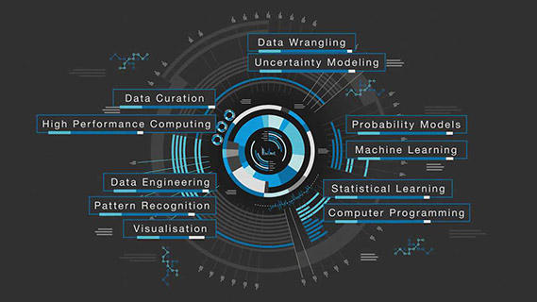

[**https://www.monash.edu/study/courses/find-a-course/2018/data-science-c6004**](https://www.monash.edu/study/courses/find-a-course/2018/data-science-c6004)

**Simplifying further:**

Ok, I do not think you are still quite satisfied with the answer so let me walk through an example.



Let’s say you are crazy about Cricket, which I am sure you are☺. Now there is an ongoing series between India and Australia. India has lost the last two matches. You are very sad and at the same time curious what will happen in the next match?

You go to Internet and see all the records of past matches between India and Australia. You observe a trend – whenever India has lost two continuous games against Australia, it has come back quite strongly in the next match. You predict that India is going to win the next match and guess what It happens.

Congratulations, you are a data scientist.

However in real life the data you will observe will not be as simple as this and probably you have to use some type of software to observe some kind of trend but the basic idea remains the same.

Data Science can be useful in making an Artificial Intelligence system-what we are going to discuss next.

**Artificial Intelligence:**

Artificial Intelligence as we call it AI is quite a broad term; it is an attempt to get computers to think like human beings. Any technique, code or algorithm that enables machines to develop, demonstrate and mimic human cognitive behavior or intelligence falls under this category. An Artificial Intelligence system can be as simple as software that plays “The Chess” to as complicated as a “Driverless Car”.

We are in an era what we call as Weak AI. In future we may move to so-called Strong AI era where there would be a system that can do literally anything a human can.

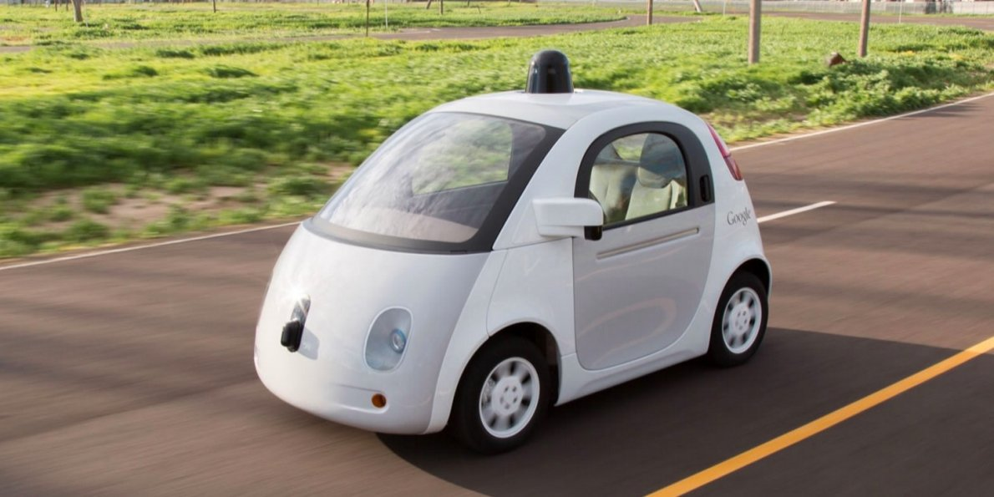

<http://www.businessinsider.com/autonomous-artificial-intelligence-is-the-real-threat-2015-9?IR=T>

**“Be careful of what you wish for”** is the tagline we can associate with Artificial Intelligence. With the emergence of AI few challenges have also emerged as a byproduct. While it’s a good thing that a driverless car can take you to your destination; but it’s not a good thing if it crashes with another car. It’s a good thing that Robots are helping in industries; but it’s not a good thing if they declare a war against human. But this is a whole different discussion may be for some other time.

**Machine Learning:**

Machine learning is probably the most frequent word you would have come across. Machine learning as the name suggest is computer’s ability to learn from a dataset and adapt accordingly without having been explicitly programmed to do so.

It’s a type of Artificial Intelligence which builds algorithms that can receive input data and use some kind of analysis to predict an output value within an acceptable range.

Machine learning algorithms come in different flavors.  Most commonly used class of algorithms is known as **"Supervised"** algorithms, because the learning is guided by observations with known outcomes—what we called as “labels”.



These are some of the examples of supervised learning.

* You get bunch of questions and answers, you train your model to build question-answer software. Whenever it encounters a new question; it gives you a suitable answer.
* Cortana or any speech automated system in your mobile phone trains your voice regularly and then starts working quite amazingly based on this training.

The second type of algorithm is known as "**Unsupervised"** and the name itself suggests what it does: unlike its counterpart it doesn't use known outcomes to guide the learning.  Clustering algorithms is one such example.



Here are some of the examples of Unsupervised Machine Learning:

* When you go to a new environment say you college. You are totally stranger, you have no idea about the people, culture or anything for that matter. But as the time passes you are able to identify and classify people; you identify you academic buildings; you identify the canteens and what not. Have you ever thought how all this was possible. It’s a clear cut example of unsupervised learning. Every day you learn one or two things and in the process you acquire enough knowledge to classify the object based on their color, shape or any other attribute.
* Every year NASA discovers new heavenly bodies and finds them altogether different from previously known astronomical objects such as - stars, planets, meteoroids, asteroids, black holes etc. What do you think how it classify them? It calculates distance from any other known objects, or observes its color, shape, temperature, radiation it is emitting, environment around it and then puts in a brand new category based on the attributes it thinks is most suitable for the classification.

I hope you have started realizing that Artificial Intelligence and Machine Learning is not quite the same thing. AI is the science for mimicking the human and machine learning is the algorithms behind it that make the machines smarter. **“So the enabler for AI is machine learning”.**

You can think it as other way around. If I write a very clever program that can show human-like behavior, we will call it as AI, but unless its parameters are automatically learned by Machine, it’s not Machine Learning.

**Deep Learning:**

**Deep learning is simply put a branch of Machine learning.** It is most popular machine learning algorithm that you will come across.

You have probably heard the name of Artificial Neural Network.  Artificial neural networks (ANNs) are a family of models inspired by biological neural networks and are used to estimate functions that can depend on a large number of inputs. Neurons (different nodes in the model) are auto connected and can communicate with each other. Weights of different neurons in final outputs are adjusted based on experience. So basically it’s an algorithm that takes large number of inputs, does some kind of calculation, and gives output which makes sense. Now “Deep learning” is artificial neural network where instead of all the neurons present in the same layer they are stacked over each other in different layers.

One more thing that differentiates “Deep Learning” from other algorithm is its ability to automatically extract features instead of manual extraction in feature engineering. Like in Image identification you do not have to specify the features based on which it will detect the Image.

Still did not get what I am saying. Do not worry.

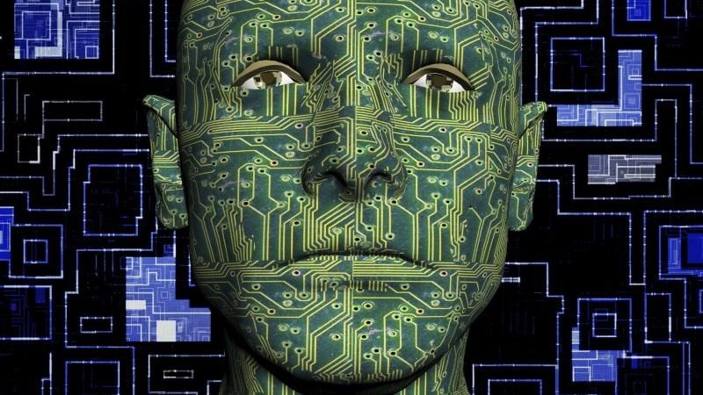

Suppose you along with you 4 friends (Number of layer) are playing a game. There is a moderator who decides the rule of the game. You and your friends are standing in a row. A picture is shown to the first person. He extracts all the information he can. Then he passes this information along the row. And finally last person in the row describes it to moderator. He will decide whether information provided by them was good enough to describe the original image, if not he will tell all you and your friends, all of you will adjust the information each time until moderator is convinced that you all are able to correctly describe the original image. This is the basic idea behind “Deep Learning”.

Now, that you have a clear cut idea of all the four concepts. Are you able to differentiate them? No-What are you saying? Really?

I am joking. I understand, it should not be quite clear yet☺. Let’s revisit them once again and try to find out what differentiates them all? Is there some kind of relationship? If yes what is it?

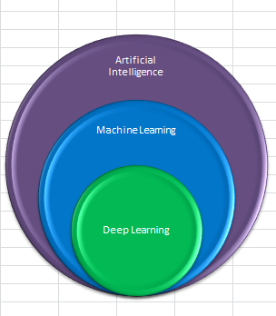

This picture clearly depicts the relationship between Artificial Intelligence, Machine Learning, and Deep Learning. It’s quite visible that Artificial Intelligence is quite a broad term. Both “Machine Learning” and “Deep Learning” are subset of it. Going further “Deep Learning” itself is a subset of “Machine Learning”.

This difference is not only in the terms of the area they cover, but also in terms of chronology.

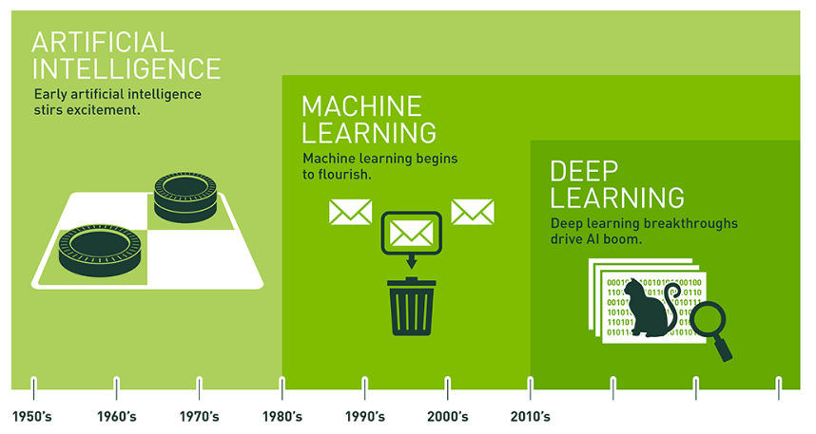

<https://blogs.nvidia.com/blog/2016/07/29/whats-difference-artificial-intelligence-machine-learning-deep-learning-ai/>

Artificial Intelligence is oldest term coined among all three. Its origin goes back to 1950s when “Turing Test” was gaining Popularity. People kept trying to develop algorithm that can help make something that can mimic a human. The first real success came in the form of “machine Learning” in 70s.

Machine learning itself was quite a groundbreaking invention but then there were limitations. Human curiosity never ends and so people were searching for more robust algorithm that can overcome limitations of Machine Learning.

It was 2010 when Google released its Google Brain Project that changed the way we look at Artificial Intelligence forever.

**Where is “Data Science” between all this?**

As we have discussed earlier Data Science is a pool of different areas involving skills and concepts from several different areas, including statistics, machine learning, and visualization. In the words of **Josh wills:**

**"Data scientist is a person who is better at statistics than any software engineer and better at software engineering than any statistician".**

**But what is the relationship with rest three?**

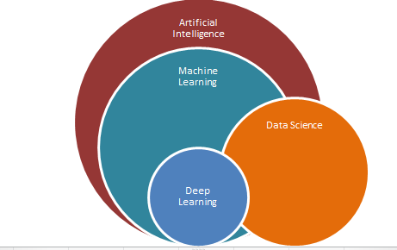

Well Data science is a fairly general term describing the analysis and manipulation of data. AI is more specific and described as a way to make something that can mimic Human i.e. which is intelligent. Talking about relationship Data Science allows for AIs to find appropriate and meaningful information from those huge data faster and more efficiently.

**Putting it all together:**

AI is a computer program that is capable of doing something smart.   
Machine learning as discussed earlier is a subset of AI. That is, all machine learning counts as AI, but not all AI counts as machine learning. For example a simple scheduling system can be classified as AI but not Machine Learning. Further Deep learning is a subfield of machine learning and both fall under the broad category of artificial intelligence.

Data science on the other hand is very general term which extracts knowledge or insights from data in various forms. It may or not relate to any of the above mentioned terms like AI, Machine Learning and Deep Learning. At the same time it may be useful in all or any of the three fields.

I hope above discussion was of some help to you and now you know the difference among all the four terms.  Crime is not that “You do not know something” but knowing something falsely is definitely a crime. ☺

If you want to try your hand with the coding part here are some of the links you can explore:

1. <https://becominghuman.ai/cheat-sheets-for-ai-neural-networks-machine-learning-deep-learning-big-data-678c51b4b463>
2. <https://machinelearningmastery.com/>
3. <https://pythonprogramming.net/>

That’s all, for today. Soon, we will come with next one in the series **“Deep Learning: Imagine the Unimaginable”** **– Implementation of Neural Network**.

**Till then; adios.**

**References:**

1. [**http://www.datasciencecentral.com/profiles/blogs/difference-between-machine-learning-data-science-ai-deep-learning**](http://www.datasciencecentral.com/profiles/blogs/difference-between-machine-learning-data-science-ai-deep-learning)
2. [**https://www.forbes.com/sites/bernardmarr/2016/12/06/what-is-the-difference-between-artificial-intelligence-and-machine-learning/#533ec18e2742**](https://www.forbes.com/sites/bernardmarr/2016/12/06/what-is-the-difference-between-artificial-intelligence-and-machine-learning/#533ec18e2742)
3. [**https://blogs.nvidia.com/blog/2016/07/29/whats-difference-artificial-intelligence-machine-learning-deep-learning-ai/**](https://blogs.nvidia.com/blog/2016/07/29/whats-difference-artificial-intelligence-machine-learning-deep-learning-ai/)